信道编码
描述
在信息传输过程中，信道是非理想带有噪声的，干扰信号可能会把接收端的0变成1或者把1变成0。在无线信道中，误码很频繁，所以我们使用汉明码来实现验错与纠错。汉明码可以纠正单个随机干扰，而对于一些信道，错误往往是突发的，即在连续的一段时间内，收到的信息全为0或者全为1。为了解决这样的问题，我们把n个编码排成一个矩阵，每次传输一列。这样即便遇到了突发干扰，对每一行来说，也只是单个错误。
现在我们有一种特殊的编码方式，它使得任意相邻两行的汉明距离<=d。问你有多少个矩阵满足这样的编码？
输入
n,m,d。表示有n个二进制串，每个串长度为m。要求相邻两个串的汉明距离<=d。对答案模1000000007
输出
一个整数表示有多少组二进制串，满足编码要求。
提示
汉明距离：两个串的不同字符个数。对于二进制串S1,S2，他们的汉明距离即为S1^S2中1的个数。
Channel coding
Description
In the process of information transmission, channel is actually not ideal and disturbance occurs from time to time. In wireless channel, bit error frequently appears and Hamming code is applied for error-checking and error recovery. Hamming code can recovery single random error, however, for some channel, burst error is more common. In order to solve such problem, we arrange the message in a matrix and send them column by column. Thus even a burst error occurs, it is single random error for each row.
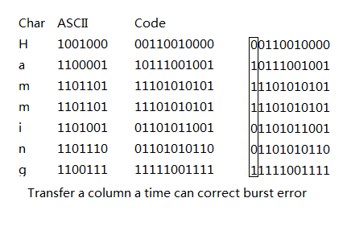
Now a mew method of coding is proposed, it requires the Hamming distance between every adjacent row less than d. And some positon of the coding is constrained to be 0 or 1. Output the number of string set that meet the demand.
Input
first line three intergers n<=50 m<=15 d<=m
n is the number of binary strings required.
m is the length of each string.
hamming distance bewteen adjacent row should be less than d.
next n lines are the constrain of each string, which only consists of '0','1',and '?'.
Output
the answer module 1000000007
Hint
Hamming distance is the number of different character in corresponding postion between two string.
for example, hamming(000,111)=3,hamming(011,111)=1

